Paula De Francisco Pérez  Performance & Marketplace Marketing · CPG Snacks  Dubai, UAE | +971 50 386 3656 | paulich98@hotmail.com  linkedin.com/in/paula-de-francisco-perez-92a13119a  Portfolio: paula-de-francisco.vercel.app  Nationality: Spanish | UAE Employment Visa (employer-sponsored) | 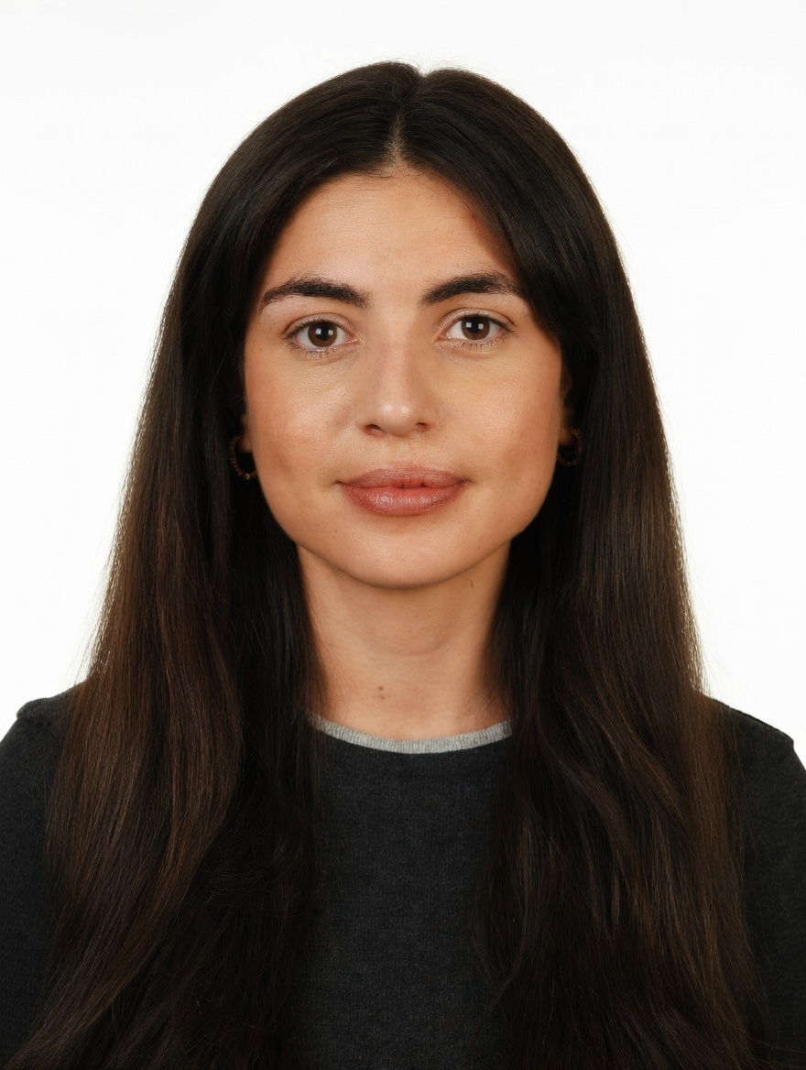
PROFESSIONAL SUMMARY

Performance and marketplace marketer with 5 years across CPG and e-commerce. At DoFreeze, runs Meta and Google Ads for a snack and bakery portfolio sold on talabat, Noon, Careem, Amazon and Shopify, budgeting on break-even ROAS net of marketplace fees and measuring incrementality against a control. Previously grew 42 brands +30% GMV QoQ at Alibaba's Miravia.
WORK EXPERIENCE

Brand & Marketing Manager | Oct 2025 – Present
DoFreeze LLC · UAE snack & bakery CPG | Befit, Eurocake, SMASH | talabat, Noon, Careem, Amazon, Shopify · Dubai, UAE
• Run paid social and search on Meta and Google Ads: built an Advantage+ catalogue retargeting campaign at 3.7x ROAS and AED 34.5 per purchase in week one; August account at 829K impressions, 2.01% CTR, AED 4.64 CPM
• Profit before volume: computed break-even ROAS per brand and channel net of marketplace commissions and moved Google spend to Meta when its return did not cover the cost
• Measure incrementality, not last touch: SMASH x talabat lifted daily sales +165% vs +4.7% for a control brand; Befit x Noon added 4,176 incremental units (+31% vs baseline)
• Own the Shopify store: web orders +86% and revenue +57% (Q1 vs Jun–Aug 2026) after reviews, basket-based bundles and a 30-day replenishment flow; Q3 conversion 2.2%, AOV ~AED 326
• Run the weekly dark-store stock-risk review for talabat, Noon and Careem on an AI dashboard built with the team; 6 product launches, incl. SMASH, now on talabat, Noon and Amazon
• Weekly creative-hook tests across 4 social accounts; influencer programme from zero (103 activations at AED 81 per content piece); Claude-based reporting automation (~40% less manual work)
Key Account Manager – Beauty, Fragrances & Fashion | Nov 2023 – Oct 2025
Miravia & AliExpress (Alibaba Group) · Marketplace | Beauty & Health department · Madrid, Spain
• Grew 42 beauty and fragrance brands (incl. L'Oréal Paris, Maybelline, NYX, Redken, KIKO Milano) +30% GMV QoQ through pricing, assortment, promotions and on-site visibility; worked with marketing, product and ops
• Owned the Flash Sales channel for Beauty, Fashion & Home (up to ~30% of B&H sales), reporting to the CEO; grew Arabian perfume into a top-growing sub-category
Account Manager – XL Accounts | Sep 2022 – Nov 2023
Glovo · Food & quick-commerce delivery app | 10K+ employees · Madrid, Spain
• Co-managed 5 XL restaurant accounts (KFC, Taco Bell, Vicio) on GMV, orders, promo spend and in-app ads; read campaign returns to pick activation days
Category Planning Trainee | Aug 2021 – Aug 2022
Mondelez International · Global snacking CPG · Madrid, Spain
• Sell-in/sell-out and promo-effectiveness analysis for chocolate; supported NPD (Milka Spread, Mini Suchard)
CORE SKILLS & TOOLS

Paid Media | Meta Ads (Advantage+, catalogue retargeting), Google Ads, budget allocation, creative testing
Marketplaces | talabat, Noon, Careem, Miravia, AliExpress, Glovo, Shopify, on-site visibility, promotions, bundles
Profitability | break-even ROAS, contribution margin, incrementality vs control, ROAS, CPA, CVR, AOV, promo uplift
Data & Analytics | Excel (Expert), Looker, Power BI, SAP, Shopify analytics, weekly KPI dashboards
AI & Tools | Claude / Claude Code (automation, dashboards), ChatGPT, Canva, Photoshop
EDUCATION

Bachelor's in Business Administration — CUNEF Universidad, Madrid | 2016 – 2020
Specialisation: E-Commerce · Fashion Industry · Thesis on e-commerce in fashion retail (9.5/10)
Google E-Commerce Certificate · Google Digital Marketing Certificate
LANGUAGES

Spanish | Native | English | Professional C1

